**Mini Project**

**The Book Shop**

**Name :- Yash Jayram Ambekar**

**Class :- TE**

**Div :- B**

**Code :-**

import java.awt.EventQueue;

import javax.swing.JFrame;

import javax.swing.JLabel;

import javax.swing.JOptionPane;

import java.awt.Font;

import javax.swing.JPanel;

import javax.swing.border.TitledBorder;

import javax.swing.JTextField;

import javax.swing.JButton;

import javax.swing.JTable;

import javax.swing.JScrollPane;

import java.awt.event.ActionListener;

import java.awt.event.ActionEvent;

import java.sql.*;

import net.proteanit.sql.DbUtils;

import java.awt.event.KeyAdapter;

import java.awt.event.KeyEvent;

public class JavaMini {

private JFrame frame;

private JTextField txtbname;

private JTextField txtedition;

private JTextField txtprice;

private JTable table;

private JTextField textField;

/**

* Launch the application.

*/

public static void main(String[] args) {

EventQueue.invokeLater(new Runnable() {

public void run() {

try {

JavaMini window = new JavaMini();

window.frame.setVisible(true);

} catch (Exception e) {

e.printStackTrace();

}

}

});

}

/**

* Create the application.

*/

public JavaMini() {

initialize();

Connect();

table_load();

}

Connection con;

PreparedStatement pst;

ResultSet rs;

// "jdbc:mysql://localhost/JavaMini","root","");

public void Connect() {

try {

Class.forName("com.mysql.cj.jdbc.Driver");

con = DriverManager.getConnection("jdbc:mysql://localhost:3306/JavaMini","root","Yash@SQL!OneShot#12");

}

catch(ClassNotFoundException ex) {

}

catch(SQLException ex) {

}

}

public void table_load() {

try {

pst = con.prepareStatement("select * from Book");

rs = pst.executeQuery();

table.setModel(DbUtils.resultSetToTableModel(rs));

}

catch(SQLException e) {

e.printStackTrace();

}

}

/**

* Initialize the contents of the frame.

*/

private void initialize() {

frame = new JFrame();

frame.setBounds(100, 100, 530, 349);

frame.setDefaultCloseOperation(JFrame.EXIT_ON_CLOSE);

frame.getContentPane().setLayout(null);

JLabel lblNewLabel = new JLabel("Book Shop");

lblNewLabel.setFont(new Font("Algerian", Font.BOLD, 28));

lblNewLabel.setBounds(180, 11, 162, 42);

frame.getContentPane().add(lblNewLabel);

JPanel panel = new JPanel();

panel.setBorder(new TitledBorder(null, "Registration", TitledBorder.LEADING, TitledBorder.TOP, null, null));

panel.setBounds(10, 49, 247, 169);

frame.getContentPane().add(panel);

panel.setLayout(null);

JLabel lblNewLabel_1 = new JLabel("Book Name");

lblNewLabel_1.setFont(new Font("Tahoma", Font.BOLD, 12));

lblNewLabel_1.setBounds(10, 24, 77, 14);

panel.add(lblNewLabel_1);

JLabel lblNewLabel_1_1 = new JLabel("Edition");

lblNewLabel_1_1.setFont(new Font("Tahoma", Font.BOLD, 12));

lblNewLabel_1_1.setBounds(10, 59, 77, 14);

panel.add(lblNewLabel_1_1);

JLabel lblNewLabel_1_2 = new JLabel("Price");

lblNewLabel_1_2.setFont(new Font("Tahoma", Font.BOLD, 12));

lblNewLabel_1_2.setBounds(10, 97, 77, 14);

panel.add(lblNewLabel_1_2);

txtbname = new JTextField();

txtbname.setBounds(97, 22, 140, 20);

panel.add(txtbname);

txtbname.setColumns(10);

txtedition = new JTextField();

txtedition.setColumns(10);

txtedition.setBounds(97, 57, 140, 20);

panel.add(txtedition);

txtprice = new JTextField();

txtprice.setColumns(10);

txtprice.setBounds(97, 95, 140, 20);

panel.add(txtprice);

JButton btnNewButton = new JButton("Save");

btnNewButton.addActionListener(new ActionListener() {

public void actionPerformed(ActionEvent e) {

String bname,edition,price;

bname = txtbname.getText();

edition = txtedition.getText();

price = txtprice.getText();

try {

pst = con.prepareStatement("insert into Book(book_name,edition,price)values(?,?,?)");

pst.setString(1,bname);

pst.setString(2, edition);

pst.setString(3, price);

pst.executeUpdate();

JOptionPane.showMessageDialog(null, "Record Added!!!");

table_load();

txtbname.setText("");

txtedition.setText("");

txtprice.setText("");

txtbname.requestFocus();

}

catch(SQLException el) {

el.printStackTrace();

}

}

});

btnNewButton.setBounds(10, 135, 57, 23);

panel.add(btnNewButton);

JButton btnNewButton_1 = new JButton("Exit");

btnNewButton_1.addActionListener(new ActionListener() {

public void actionPerformed(ActionEvent e) {

System.exit(0);

}

});

btnNewButton_1.setBounds(180, 135, 57, 23);

panel.add(btnNewButton_1);

JButton btnClear = new JButton("Clear");

btnClear.addActionListener(new ActionListener() {

public void actionPerformed(ActionEvent e) {

try {

txtbname.setText("");

txtedition.setText("");

txtprice.setText("");

txtbname.requestFocus();

}

catch(Exception el) {

el.printStackTrace();

}

}

});

btnClear.setBounds(97, 135, 57, 23);

panel.add(btnClear);

JScrollPane scrollPane = new JScrollPane();

scrollPane.setBounds(267, 54, 236, 177);

frame.getContentPane().add(scrollPane);

table = new JTable();

scrollPane.setViewportView(table);

JPanel panel_1 = new JPanel();

panel_1.setBorder(new TitledBorder(null, "Search", TitledBorder.LEADING, TitledBorder.TOP, null, null));

panel_1.setBounds(10, 229, 247, 56);

frame.getContentPane().add(panel_1);

panel_1.setLayout(null);

JLabel lblNewLabel_1_1_1 = new JLabel("Book ID");

lblNewLabel_1_1_1.setBounds(10, 23, 66, 15);

lblNewLabel_1_1_1.setFont(new Font("Tahoma", Font.BOLD, 12));

panel_1.add(lblNewLabel_1_1_1);

textField = new JTextField();

textField.addKeyListener(new KeyAdapter() {

@Override

public void keyReleased(KeyEvent e) {

try {

String id = textField.getText();

pst = con.prepareStatement("select book_name,edition,price from Book where id=?");

pst.setString(1, id);

ResultSet rs = pst.executeQuery();

if(rs.next() == true) {

String name = rs.getString(1);

String edition = rs.getString(2);

String price = rs.getString(3);

txtbname.setText(name);

txtedition.setText(edition);

txtprice.setText(price);

}

else {

txtbname.setText("");

txtedition.setText("");

txtprice.setText("");

}

}

catch(SQLException el) {

el.printStackTrace();

}

}

});

textField.setBounds(99, 21, 138, 20);

textField.setColumns(10);

panel_1.add(textField);

JButton btnNewButton_2 = new JButton("Update");

btnNewButton_2.addActionListener(new ActionListener() {

public void actionPerformed(ActionEvent e) {

String bname,edition,price,bid;

bname = txtbname.getText();

edition = txtedition.getText();

price = txtprice.getText();

bid = textField.getText();

try {

pst = con.prepareStatement("update Book set book_name=?,edition=?,price=? where id=?");

pst.setString(1,bname);

pst.setString(2, edition);

pst.setString(3, price);

pst.setString(4, bid);

pst.executeUpdate();

JOptionPane.showMessageDialog(null, "Record Updated!!!");

table_load();

txtbname.setText("");

txtedition.setText("");

txtprice.setText("");

txtbname.requestFocus();

}

catch(SQLException el) {

el.printStackTrace();

}

}

});

btnNewButton_2.setBounds(285, 243, 77, 42);

frame.getContentPane().add(btnNewButton_2);

JButton btnNewButton_3 = new JButton("Delete");

btnNewButton_3.addActionListener(new ActionListener() {

public void actionPerformed(ActionEvent e) {

String bid;

bid = textField.getText();

try {

pst = con.prepareStatement("delete from Book where id=?");

pst.setString(1, bid);

pst.executeUpdate();

JOptionPane.showMessageDialog(null, "Record Deleted!!!");

table_load();

txtbname.setText("");

txtedition.setText("");

txtprice.setText("");

txtbname.requestFocus();

}

catch(SQLException el) {

el.printStackTrace();

}

}

});

btnNewButton_3.setBounds(397, 243, 77, 42);

frame.getContentPane().add(btnNewButton_3);

}

}

**Output :-**

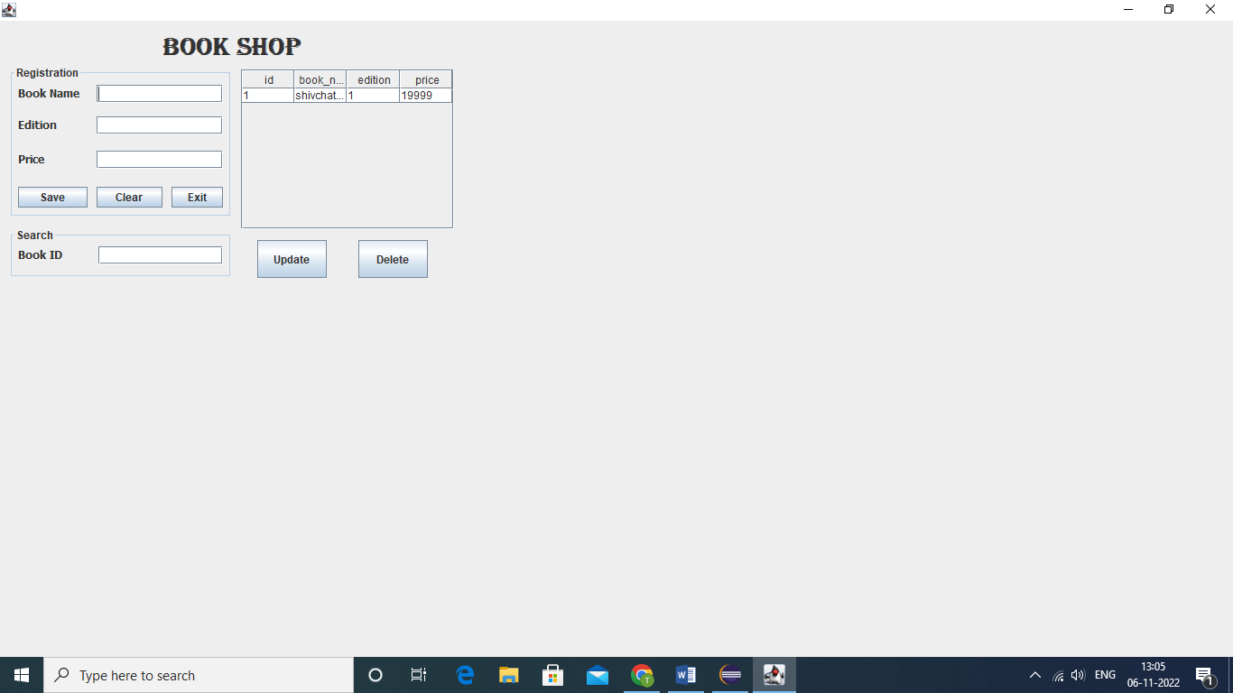

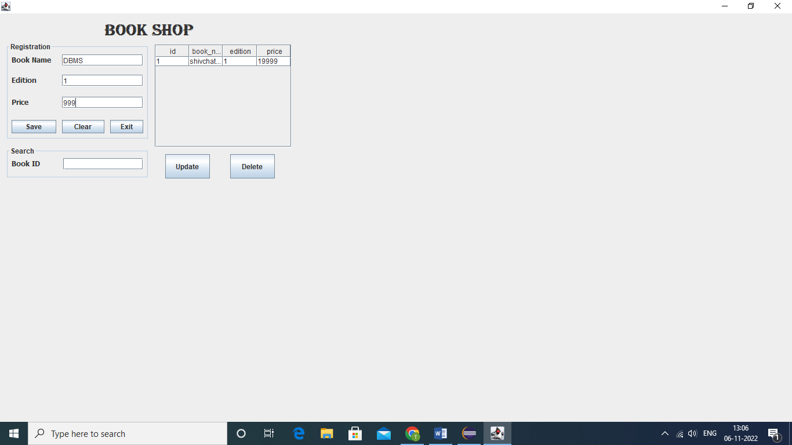

**Click To save** **record**

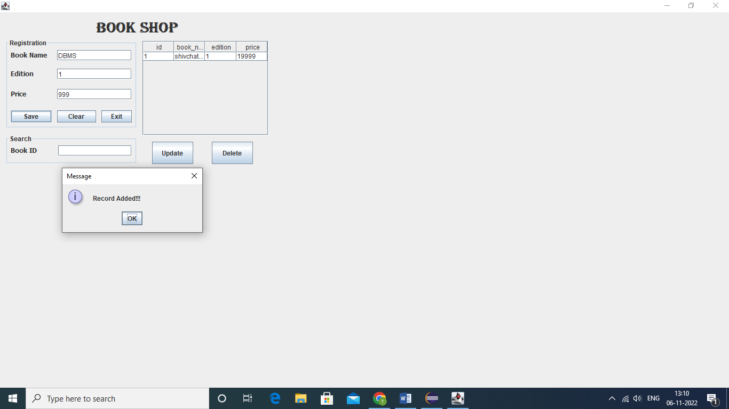

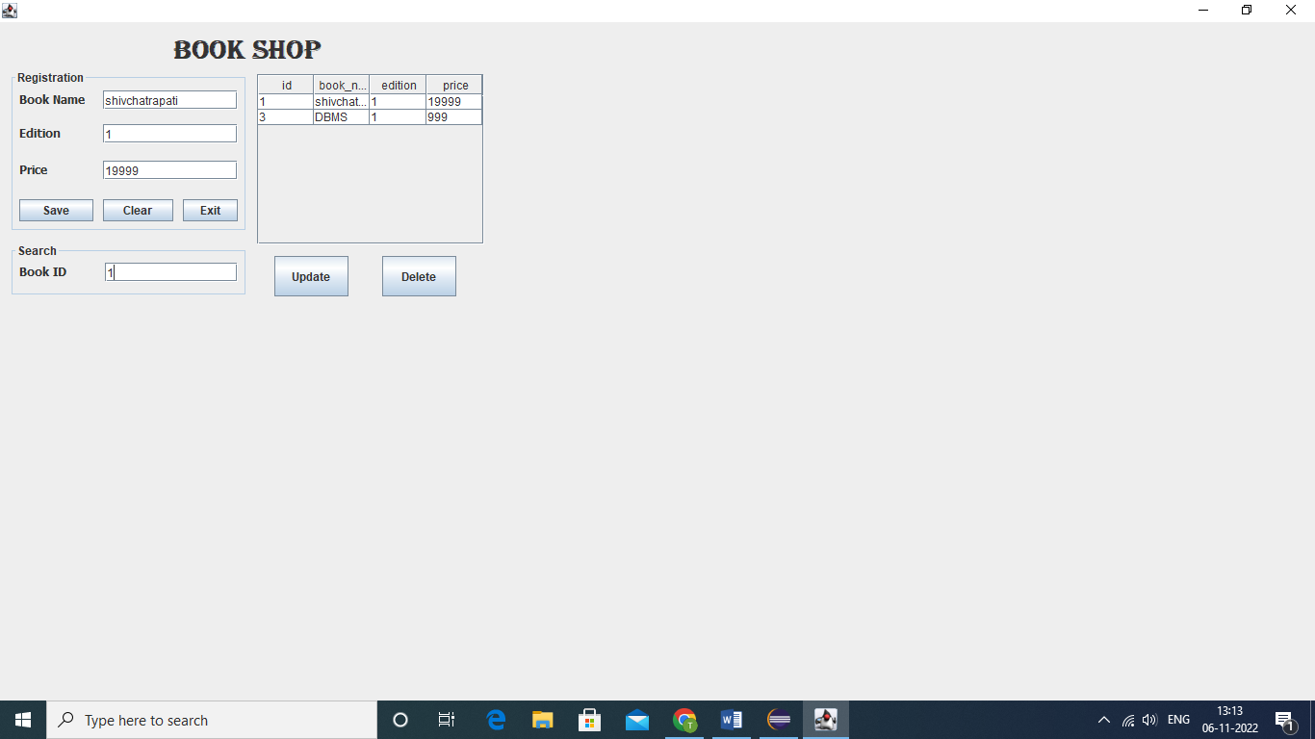

**Record with respective book id appears in the above Text fields.**

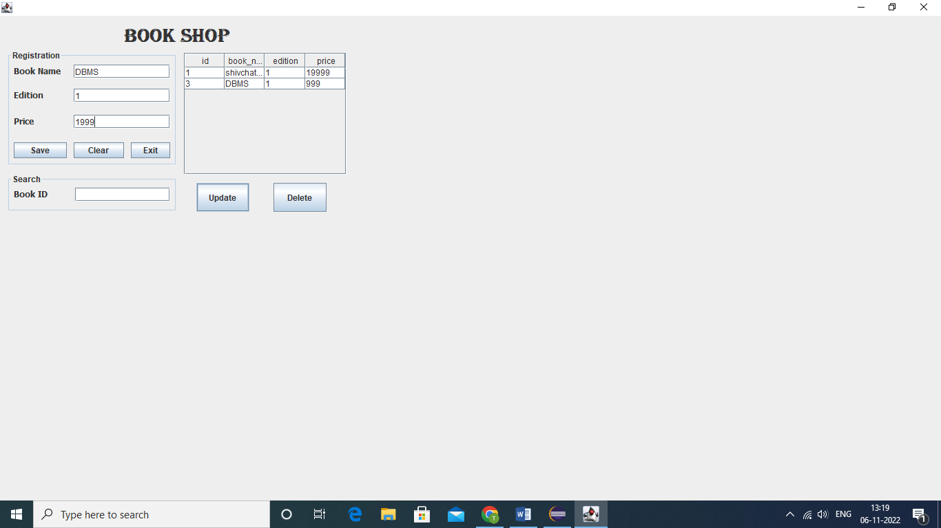

**Press the update Button**

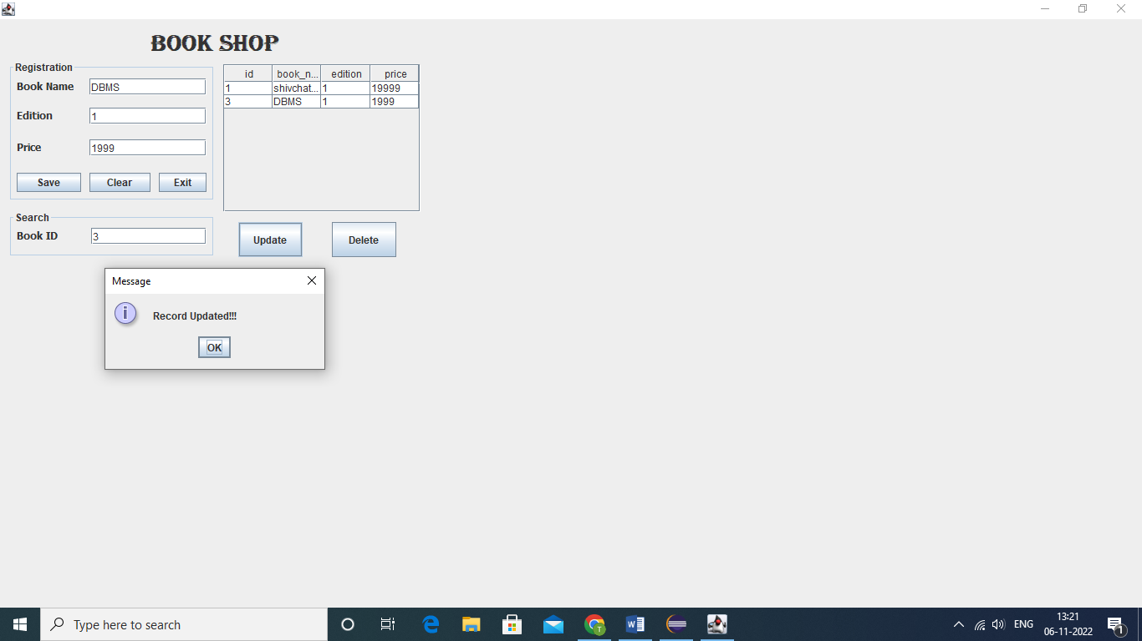

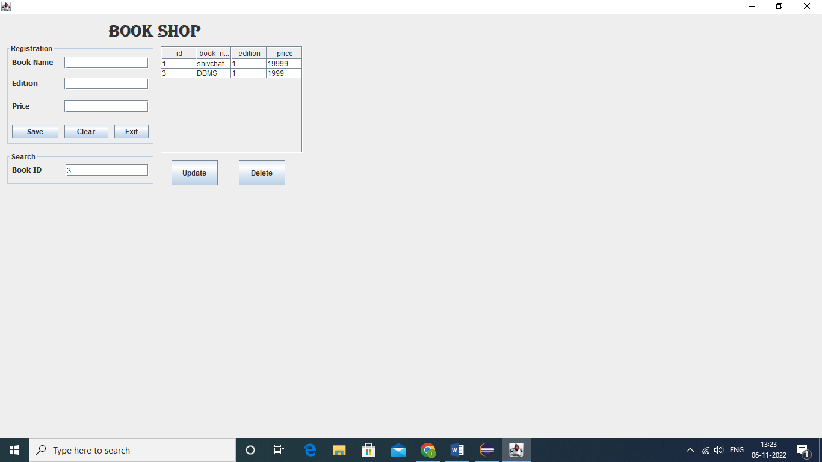

**Enter Id of Record to be deleted**

